**Report on Earthquake Magnitude Data Analysis**

Author: Kevin(Jiancong) Zhu

Date: 10/03/2024

**1. Introduction**

Understanding earthquake magnitudes is crucial for assessing risk and preparing for potential seismic events. The dataset analyzed in this project consists of earthquake magnitude values, reflecting the intensity of seismic events. So the primary goal of this analysis is to explore the characteristics of the magnitude data, assess its distribution, and derive key statistical measures so that we can provide insights into the frequency and severity of earthquakes.

**2. Exploratory Data Analysis**

To explore the dataset, various statistical measures and visualizations were calculated and created, including boxplots and histograms.

**2.1 Descriptive Statistics**

The initial step involved calculating fundamental descriptive statistics by using the function summary(), such as the mean, median, mode, range, standard deviation, and quartiles. The results indicate:

* **Mean:** The average magnitude is approximately 1.234, and this indicating that most earthquakes recorded are of lower intensity, suggesting that minor earthquakes are more common.
* **Median:** The median value, representing the middle point of the dataset, is 1.10. this indicates that half of the earthquake magnitudes are below 1.10, while the other half are above. This reinforces the notion that lower magnitudes are prevalent.
* **Mode:** The most frequently occurring magnitude value is 1.00, and it signifies that this is the most frequently occurring magnitude, further emphasizing the tendency towards lower magnitude events.
* **Range:** The difference between the maximum and minimum magnitudes is 3.45 - 0.10 = 3.35. from a minimum of 0.10 to a maximum of 3.45, indicates a broad spread of magnitudes, highlighting the presence of some significant seismic events
* **Standard Deviation:** The standard deviation, which measures the dispersion of the magnitudes from the mean, is approximately 0.663. so this suggests a moderate level of dispersion around the mean, indicating that while most magnitudes are clustered around the average, there are notable variations.





**2.2 Visualizations**

The analysis utilized boxplots and histograms to visualize the magnitude data:

* **Boxplot of Magnitude:** This visualization displays the median, quartiles, and potential outliers in the dataset. The boxplot indicates a central tendency around 1.25, with some outliers present above 2.5. This suggests that while most earthquake magnitudes fall below 2.0, there are a few significant seismic events that exceed this value.
* **Histogram of Magnitude:** The histogram illustrates the frequency distribution of earthquake magnitudes. The shape of the histogram shows a right-skewed distribution, with a higher frequency of lower magnitudes (0.0 - 1.5) and decreasing frequency as the magnitude increases.

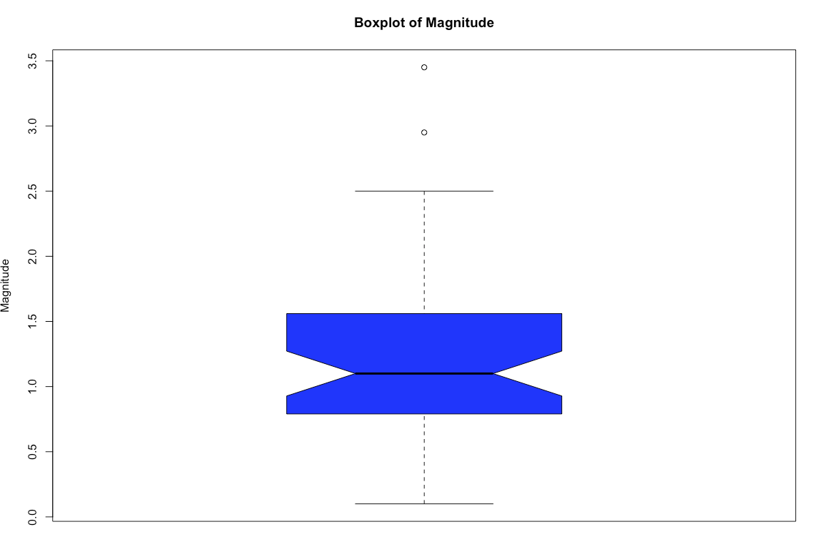

**3. Data Analysis Methodologies**

Several statistical methodologies were employed to analyze the earthquake magnitude data:

* **Descriptive Statistics:** These provide a summary of the dataset, allowing for an understanding of central tendencies and dispersion.
* **Boxplots and Histograms:** These visual tools help in identifying the distribution and spread of the data, revealing patterns and potential outliers.
* **Quantitative Analysis:** The Winsorized sample standard deviation was computed to minimize the impact of outliers, providing a more robust measure of variation. Additionally, the trimmed mean was calculated to further refine the average magnitude by reducing the influence of extreme values.

The analysis reveals that most earthquake magnitudes tend to be low, with the frequency of higher magnitudes diminishing significantly. This information can aid in understanding the seismic activity level and risk assessment in relevant regions.

**4. Conclusion**

This project successfully analyzed earthquake magnitude data, providing insights into its distribution and key statistical characteristics. The exploratory data analysis highlighted the prevalence of lower magnitudes, while the boxplot and histogram effectively illustrated the underlying distribution. Understanding these characteristics is crucial for seismologists and disaster preparedness agencies in predicting seismic events and implementing safety measures. Further research could explore the relationship between magnitude and other seismic factors, such as depth and location, to enhance predictive modeling and risk assessment efforts.